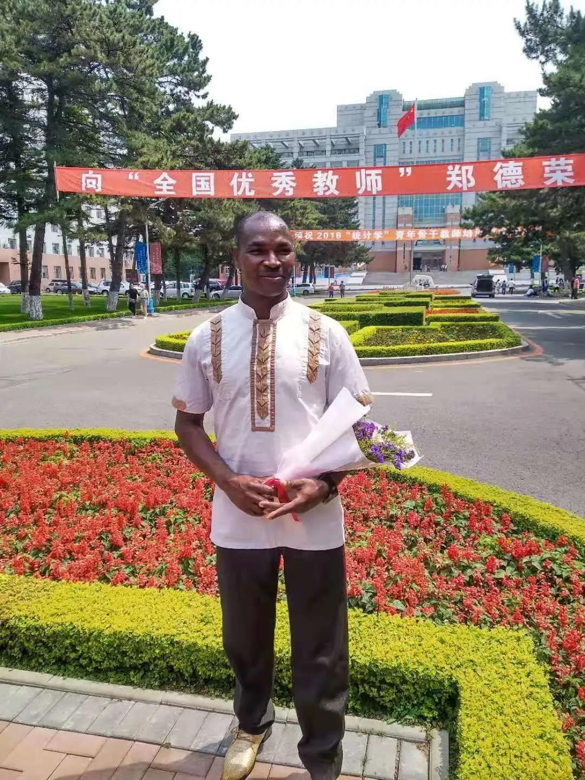

It is a great honour for me and my family to receive this noble Award as Chinese Government Outstanding International Student of the Ministry of Education. I thank Chinese government for giving me this opportunity to study in China, which forms the bases of this Award. I am most grateful to all the staffs of the International students office and the School of Chemistry of Northeast Normal University.
I deeply expresses heartfelt and special thanks to my supervisor, Prof. Xiaohong Wang, for accepting me to study in her great laboratory, providing academic guidance and support for me to excel. She is a wonderful supervisor and mentor. I am equally grateful to my laboratory mates for the team spirit and support during our experiments. My sincere gratitude goes to Hon. Donimic Nitiwul in Ghana for giving me the opportunity and support to come and study in China. Special thanks to my family and friends for their prayers and support in the cause of my study.
It is my joy to say that Chinese government scholarship program has undoubtedly enabled me and other students from every part of the world to sharpen our learning and research skills. Studying in China has given me so many opportunities to interact with people from different cultural background and appreciate better the value that China brings to global development. China has a unique culture, beautiful and peaceful environment for life and academic work. I and the students of Ghana will forever be thankful to NENU and China.
能获得中国政府优秀来华留学生这一崇高奖项，我和我的家人都深感荣幸。十分感谢中国政府给我这次在中国学习的机会，使我有机会获得这一奖项。我也非常感谢东北师范大学留学生办公室和化学学院的所有老师们。
我衷心感谢我的导师王晓红教授接收我到她的实验室进行学习，为我提供学术指导和支持，她是一位十分出色的学术和思想导师。我同样感谢实验室的其他同学在学习中所给予的团队精神和支持。同时，我也真诚地感谢加纳的Hon. Donimic Nitiwul给我来中国学习的机会，特别感谢家人和朋友对我学习的帮助和支持。
我很高兴地说，中国政府奖学金项目无疑帮助我和其他来自世界各地的学生提高了学习和研究能力。在中国学习让我有很多机会与来自不同文化背景的人进行交流，更好地体会到中国给全球发展带来的价值。中国有独特的文化，拥有美丽而和平的生活和学术工作环境。我还有加纳的其他学生将永远感谢中国和东师。（译文）

MBAGE BAWA

